*A Mariner White Paper*

**

**Tableau versus Power Pivot:**

**The Basics**

*By Brad Llewellyn, Associate Data Analytics Consultant*

2719 Coltsgate Road • Charlotte, NC 28211

tel. 704.540-9500 • fax. 704.540-9501

[www.mariner-usa.com](http://www.mariner-usa.com)

[Description: Linkedin](http://www.linkedin.com/in/javierguillen) [Description: Twitter](http://twitter.com/javiguillen) [](http://blog.mariner-usa.com/) [Facebook](http://www.facebook.com/pages/Mariner/189095341130729)

©2013 MARINER, All Rights Reserved.

Contents of this document are proprietary and may not be distributed without the prior written consent.

# Contents

Contents 2

Abstract 3

Basic Functionality 4

Basic Charting 10

Basic Data Modeling 18

KPIs 31

Summary Results 41

About the Author 42

 42

Brad Llewellyn, Associate Data Analytics Consultant 42

About Mariner 42

Copyright Information 42

# Abstract

The purpose of this white paper is to compare two of the leading tools for Self-Service BI, Tableau and Power Pivot. There seems to be a stigma around these tools saying that Tableau is a visualization tool and Power Pivot is a data modeling tool. Is this really true? That’s what we’re here to find out. This type of examination was done about three years ago.  Click [here](http://sqlmag.com/blog/microsoft-powerpivot-vs-tableau) if you would like to read it.   Many of the flaws listed for Tableau have been worked out in the newer releases, while Power Pivot has not gotten the same treatment.  This is a major issue when comparing purchased products to free products.  However, our examination is from the user's perspective.  This means that current and future functionality must be considered, as well as pricing.

In this paper, we will examine the following types of tasks in these tools, Basic Functionality, Basic Charting, Basic Data Modeling and KPIs. If you are in a rush, the results can be found in the Results section. However, if you are serious about examining these two products, then you should definitely take the time to read this. Don’t be overwhelmed by the page numbers. We are examining two very visual tools from a user’s perspective. Therefore, there are a lot of pictures. We welcome you to join us as we get to the bottom of this question, once and for all.

# Basic Functionality

This section will examine these tools on three concepts: Data Connectivity, Quick Answers from Clean Data and Basic Typecasting. In this section, we will use the Superstore Sales sample data set from Tableau.

**Built-In Data Connectivity**

|  |  |  |
| --- | --- | --- |
| **Connection Type** | **Tableau** | **Power Pivot** |
| Microsoft Access | X | X |
| Microsoft Excel | X | X |
| Text File | X | X |
| Actian Vectorwise | X |  |
| Aster Database | X |  |
| Cloudera Hadoop | X |  |
| DataStax Enterprise | X |  |
| EMC Greenplum | X |  |
| Firebird | X |  |
| Google Analytics | X |  |
| Google BigQuery | X |  |
| Hortonworks Hadoop Hive | X |  |
| HP Vertica | X |  |
| IBM DB2 | X | X |
| IBM Netezza | X |  |
| Informix |  | X |
| MapR Hadoop Hive | X |  |
| Microsoft Analysis Services | X | X |
| Microsoft Reporting Services |  | X |
| Microsoft PowerPivot | X |  |
| Microsoft SQL Server | X | X |
| Microsoft SQL Azure |  | X |
| Microsoft SQL Server Parallel Data Warehouse |  | X |
| MySQL | X |  |
| OData | X | X |
| Oracle | X | X |
| Oracle Essbase | X |  |
| ParAccel | X |  |
| PostgreSQL | X |  |
| Progress OpenEdge | X |  |
| Salesforce | X |  |
| SAP HANA | X |  |
| SAP Netweaver Business Warehouse | X |  |
| SAP Sybase IQ | X | X |
| Teradata | X | X |
| Windows Azure Marketplace | X | X |
| ODBC | X | X |
| Data Feeds |  | X |

It doesn't take long to see that Tableau can connect to everything that Power Pivot can, plus a lot more.  Tableau can even connect to Power Pivot, while the reverse would require copy-pasting into Excel first.  Power Pivot seems to focus on Microsoft products almost exclusively.  They added connectivity to some of their major competitors, such as Oracle and Teradata, but not much else.  This seems to be the advantage of a purchased stand-alone product over a free add-in.  In fairness, you could connect to some, maybe even most, of these data sources with another type of connector and a little ingenuity.  However, this is a test of "BASIC" functionality.  Anything requiring advanced knowledge is off-limits for now.

*Winner: Tableau*

**Quick Answers from Clean Data**

This section will examine how quickly a user can get basic information about clean data using these programs.  We will assume that the data can be easily pulled into these programs.  To keep it simple, let's get Profit by Region.

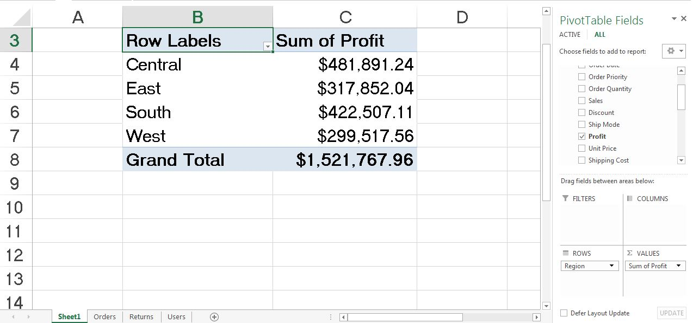

Profit by Region

With Power Pivot’s simple drag-and-drop interface, this took a couple of seconds.

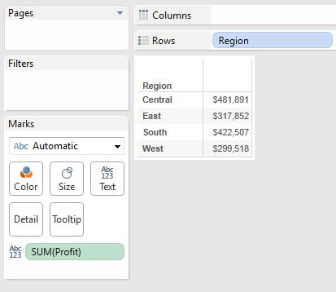

Profit by Region (Tableau)

Ditto for Tableau.  I will give Power Pivot one advantage in that it automatically gives you totals and subtotals while Tableau does not. Power Pivot displays this “Row Labels” label which is not very pleasing to me. However, Tableau does not display “Sum of Profit” at all. Therefore, we must declare Power Pivot the winner for this piece.

*Winner: Power Pivot*

**Basic Typecasting**

In this section, we will look at how each program handles changing data types.  We will do two things here.  First, we will change a numeric to a currency.  Then, we will change a string version of a number to a number.

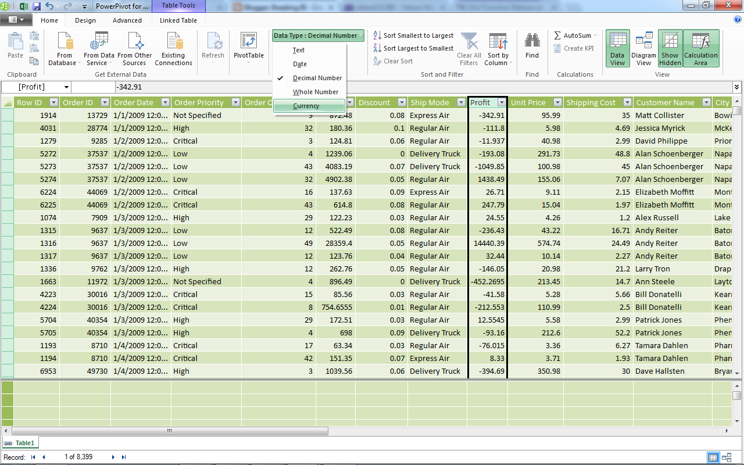

Decimal to Currency (Power Pivot)

This was just a couple of clicks away in Power Pivot.

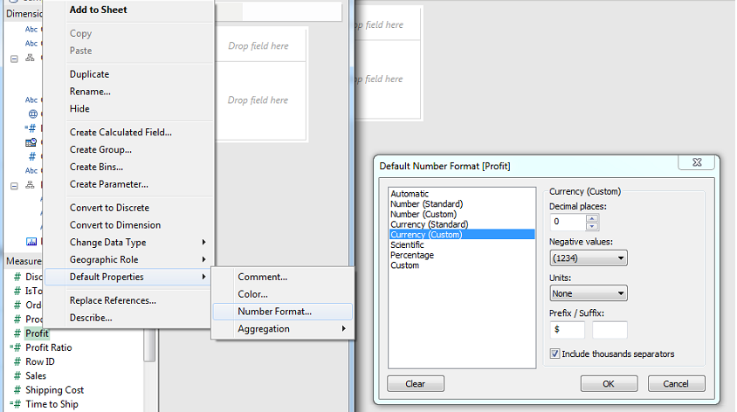

Decimal to Currency (Tableau)

This was slightly more complex in Tableau because we had to go through two menus to get here.  To be clear, Power Pivot has a currency data type, while Tableau does not.  Tableau simply considers the data to be numeric and currency is a display type.  If we were to change the display type to currency in Power Pivot, we would have to go through the Excel Format Font options, which would be just as complex as Tableau.  We don't see why having a currency data type is important (all formulas will see it as a number!).  Therefore, we will consider this part a draw.  For future reference, unnecessary features will not grant you extra credit from this council. Next, let's look at how easy it is to actually change a data type in these tools.

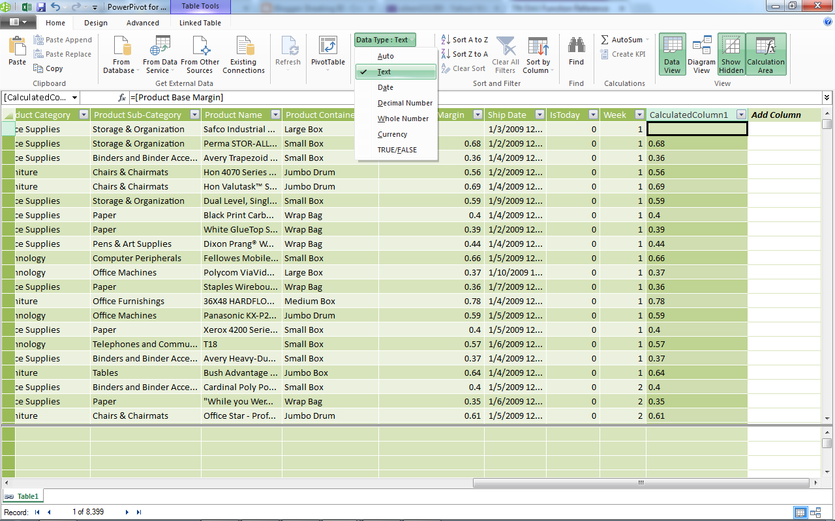

Decimal to Text (Power Pivot)

Once again, the handy data type drop-down saves us again.  Power Pivot completed this task in a couple of clicks.

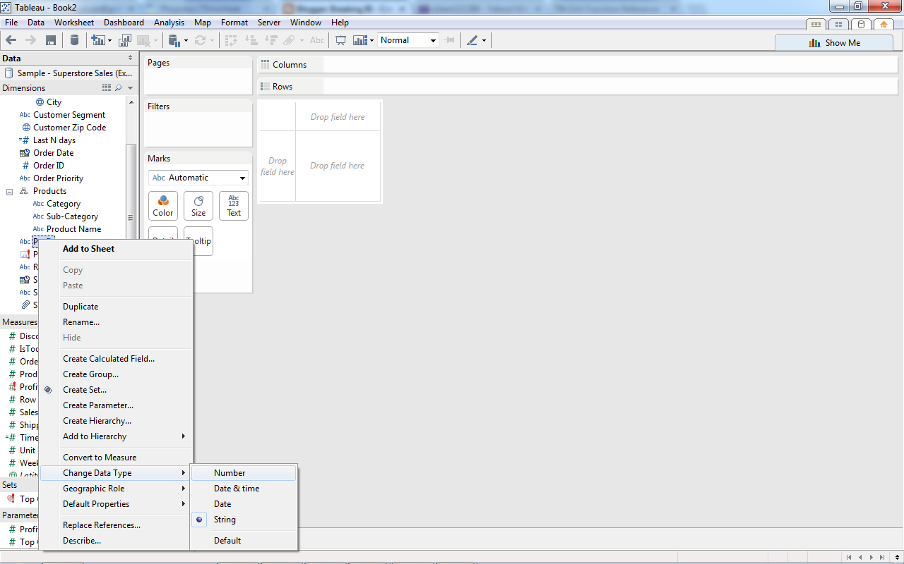

Decimal to Text (Tableau)

Ditto again for Tableau.  It has the same menu feature as Power Pivot.  However, when you cast a measure to a dimension, or vice-versa, in Tableau, you have to manually drag the field to the appropriate shelf, which is one extra step that Power Pivot does not have.  Therefore, Power Pivot is better at this (by a hair).

*Winner: Power Pivot*

**Section Summary**

As a simple recap of Basic Functionality, Tableau destroyed Power Pivot with its ability to easily connect to different data sources.  However, Power Pivot edged out Tableau in its ability to typecast fields.

# Basic Charting

In this section, we will talk about creating basic charts in Tableau and Power Pivot.  To be specific, Power Pivot cannot create charts.  To create charts out of Power Pivot, you must either use Excel or Power View.  We will examine both of these as options. We will create the following charts: One-Dimensional Bar Graph, Two-Dimensional Bar Graph and Scatterplot. In this section, we will use the Superstore Sales sample data set from Tableau.

**Bar Graph (1 measure by 1 dimension)**

The bar graph is most common of chart types and is useful for almost any type of analysis.  So, let's look at Profit by Region.

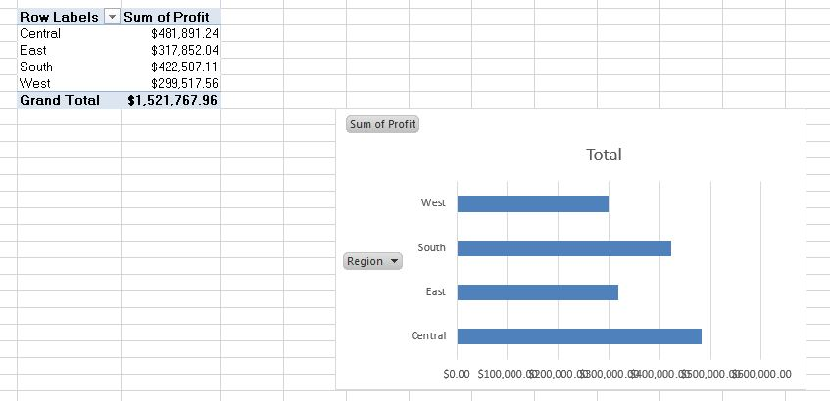

Profit by Region (Bar) (Excel)

This wasn't too hard in Excel.  However, it required us to first create the pivot table, then create the chart.  The labels and axes are also somewhat lacking.  More effort would have to be put into this to make it presentable.  Let's see how Power View fares.

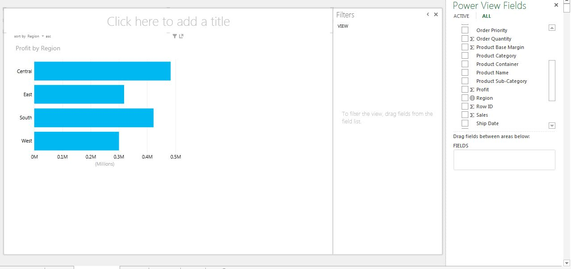

Profit by Region (Bar) (Power View)

This was much easier than Excel.  The drag-and-drop interface makes everything much easier.  Also, the labels are very intuitive.  The graph is more aesthetically pleasing as well.  The only issue was that I had to resize the chart to see it all.  Finally, let's check out Tableau.

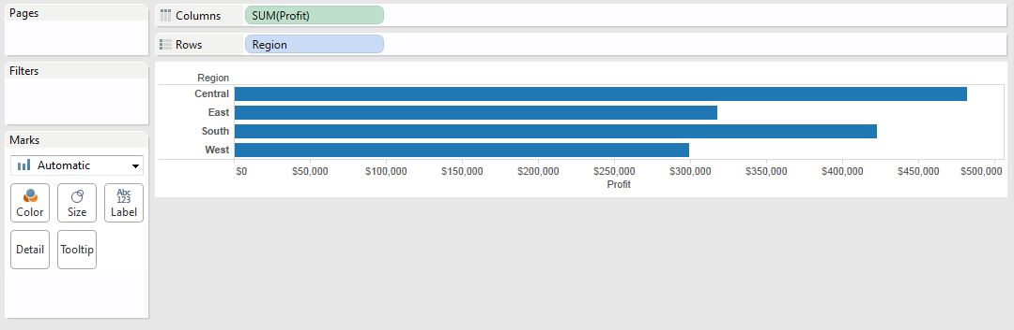

Profit by Region (Bar) (Tableau)

This was even easier than Power View.  I created this graph in two clicks, compared to four in Power View and much more in Excel.  I would say the aesthetics between Tableau and Power View are about equal.  This is the power behind these two tools after all.  It seems that Tableau has edged this one out ever so slightly.

*Winner: Tableau*

**Bar Graph (1 measure by 2 dimensions)**

Due to their interpretability, let's stay with bar graphs.  However, let's crank it up a notch and add a second dimension.  Let's see what Profit by Region and Category gives us.

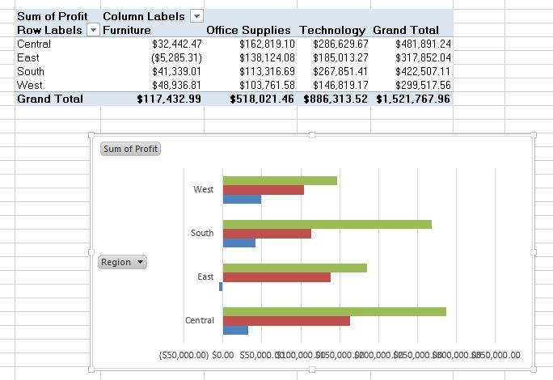

Profit by Region and Category (Bar) (Excel)

Again, this wasn't too difficult.  Excel chose the roles intuitively, putting Region on the Rows and Category on the Colors.  This still required us to create the pivot table independent of the chart.  Also, we're still not impressed with the aesthetics or labels of the chart.  Finally, the label for the colors doesn't automatically appear, which could lead to confusion.  Let's see what Power View offers.

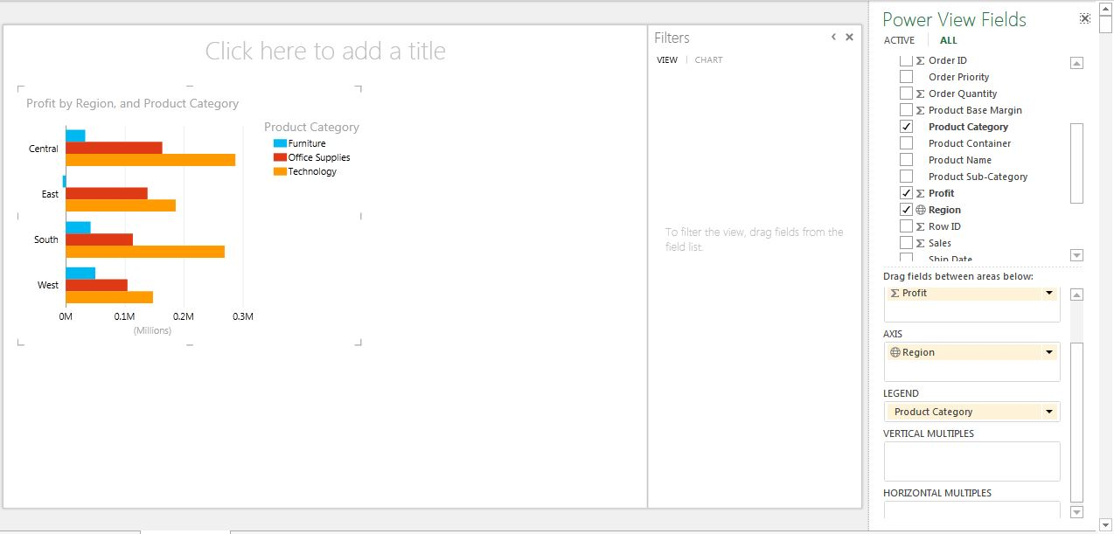

Profit by Region and Category (Bar) (Power View)

Just like last time, this was just a couple of clicks.  The labels and the aesthetics are acceptable.  My only concern about this chart is that the colors are a little too eye-catching for my taste.  A slightly softer palette would be nice in this case.  Now, on to Tableau.

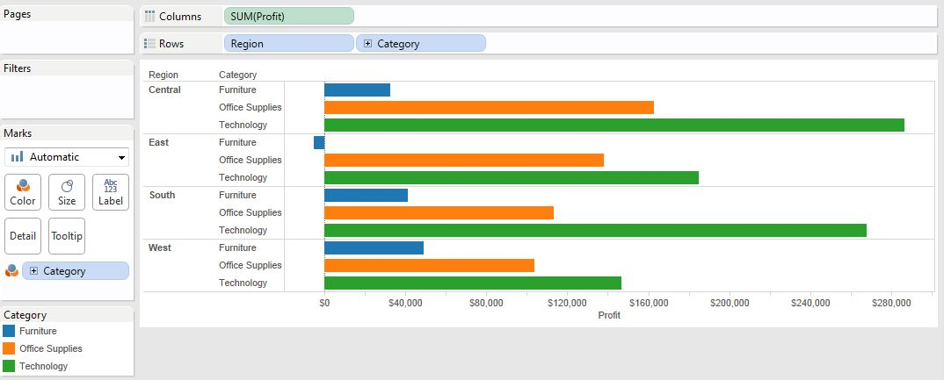

Profit by Region and Category (Bar) (Tableau)

This was actually more complex than Power View.  In Power View, all I had to do was drag Category to the Legend Shelf.  In Tableau, I had to drag it to both the Rows Shelf and the Colors Shelf.  To our knowledge, Tableau is incapable of making clustered bar graphs.  This is probably our biggest frustration with Tableau.  How can a tool that is so good as visualizations lack such a simple feature?  Alas, we digress.  The point is this: not only was this chart more complex to make in Tableau than in Power View, it looks pretty unappealing.  As much as it pains me (a Tableau fanboy) to say it, Power View wins this one pretty convincingly.

*Winner: Power View*

**Scatterplot (2 measures by 2 dimensions)**

Now we're getting to the neat stuff.  How well can these tools handle dense graphs?  Let's try plotting Sales and Profit by Region and Customer (A hierarchical relationship!).

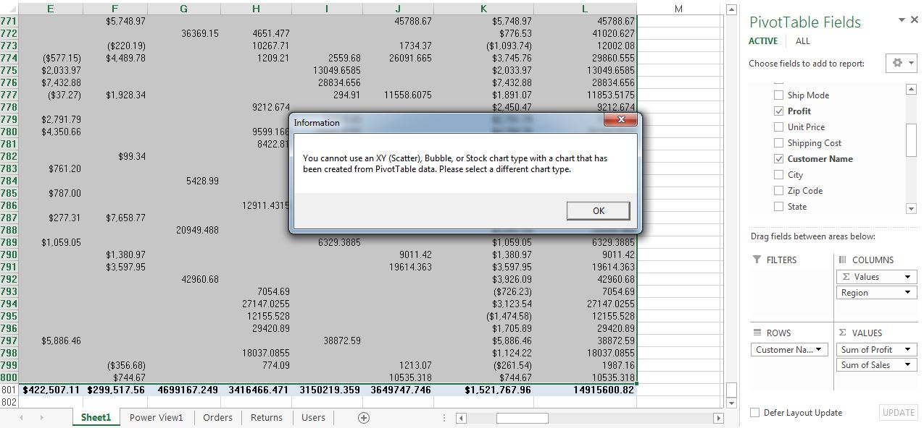

Sales and Profit by Region and Customer (Scatterplot) (Excel)

Turns out, Excel can't even do this (at least not simply).  This is all we needed to see.  Moving on to Power View.

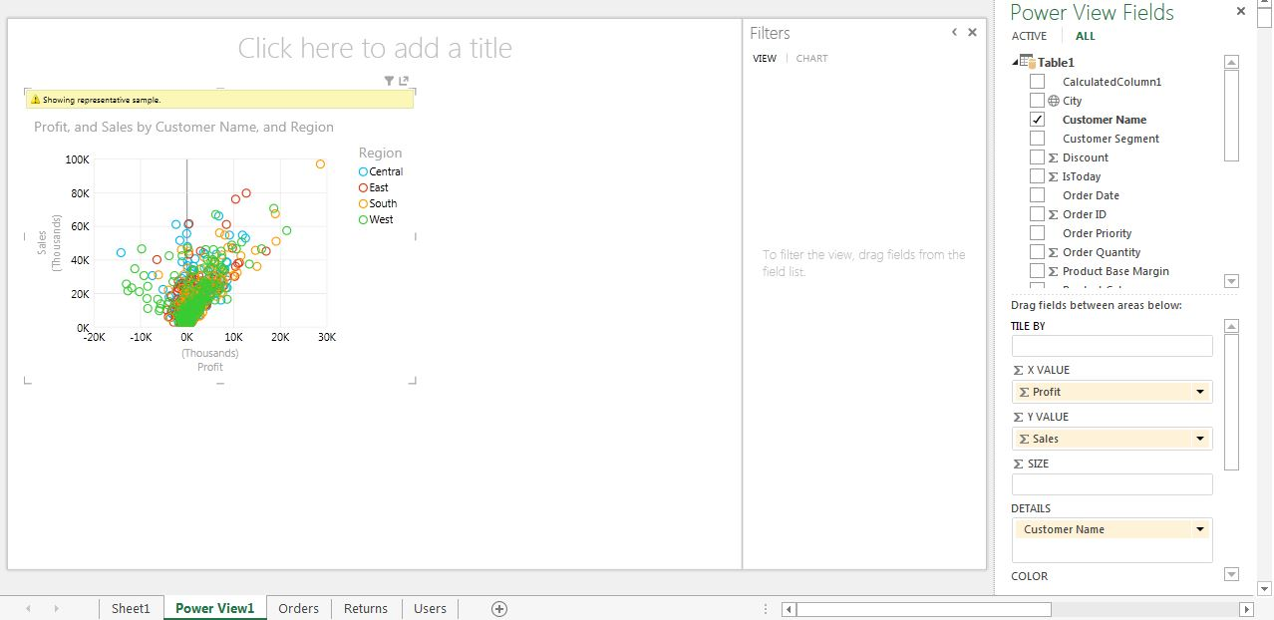

Sales and Profit by Region and Customer (Scatterplot) (Power View)

This wasn't a very difficult task in Power View.  We also like the aesthetics of the graph.  All-in-all, this isn't a bad chart.  However, one of our biggest concerns with Power View is that it shows representative samples when the amount of points gets large.  This makes outlier detection nearly impossible.  If there is a way to turn this off, we haven't found it.  This being said, Power View doesn't seem to be a good tool for this type of chart.  Let's see what Tableau offers.

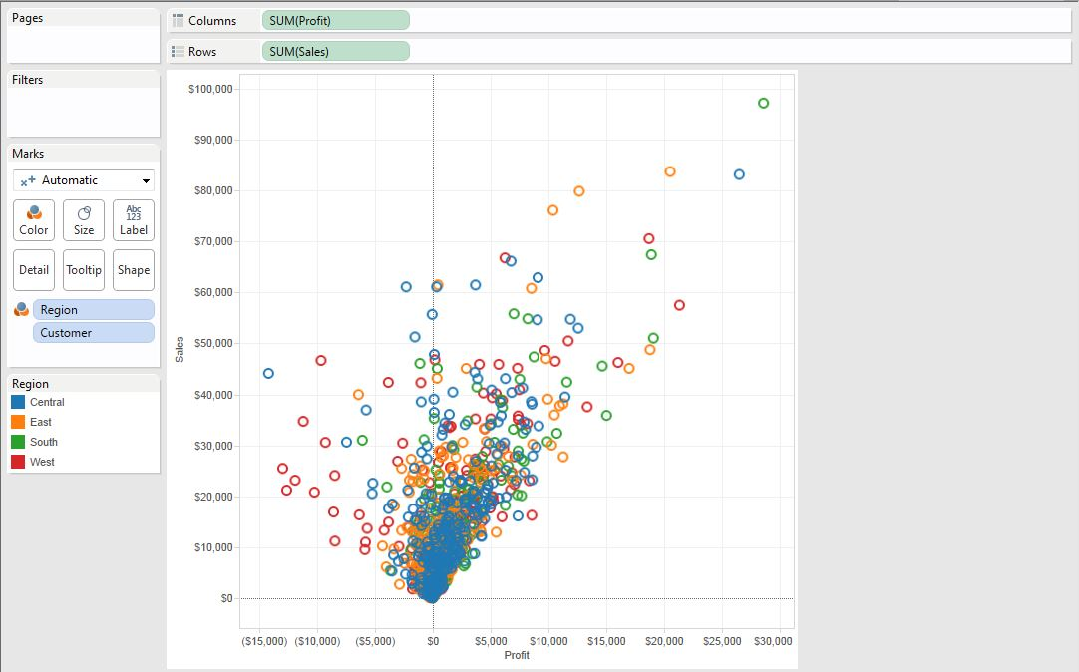

Sales and Profit by Region and Customer (Scatterplot) (Tableau)

This chart was no more difficult to make than the Power View chart.  However, it shows all the points.  Notice all of those outliers in the top-right of the chart?  We were missing most of those in the Power View chart.  Also, this graph just looks slightly cleaner to us.  Looking at this, it's easy to say that Tableau is the winner here.

*Winner: Tableau*

**Mapping (1 measure by 1 geographic dimension)**

Mapping is a newer type of technology that is becoming more mainstream.  Let's see how these tools handle it.  We'll try Profit by State.

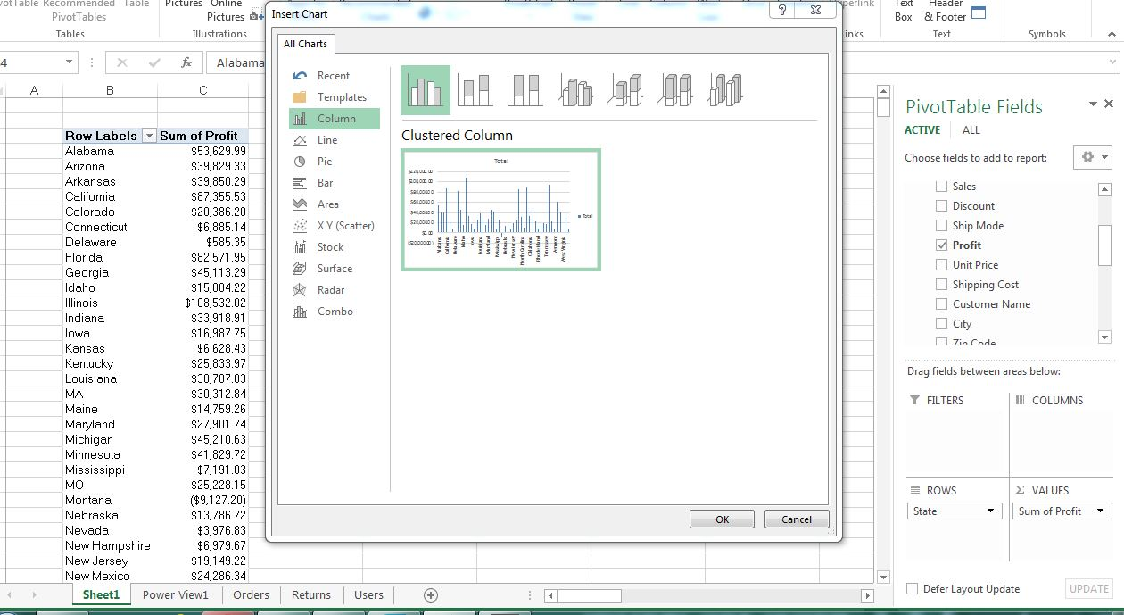

Profit by State (Map) (Excel)

We couldn't even find a mapping feature in Excel.  If it's there, it's wasn't obvious to us.  Now, let's look at Power View.

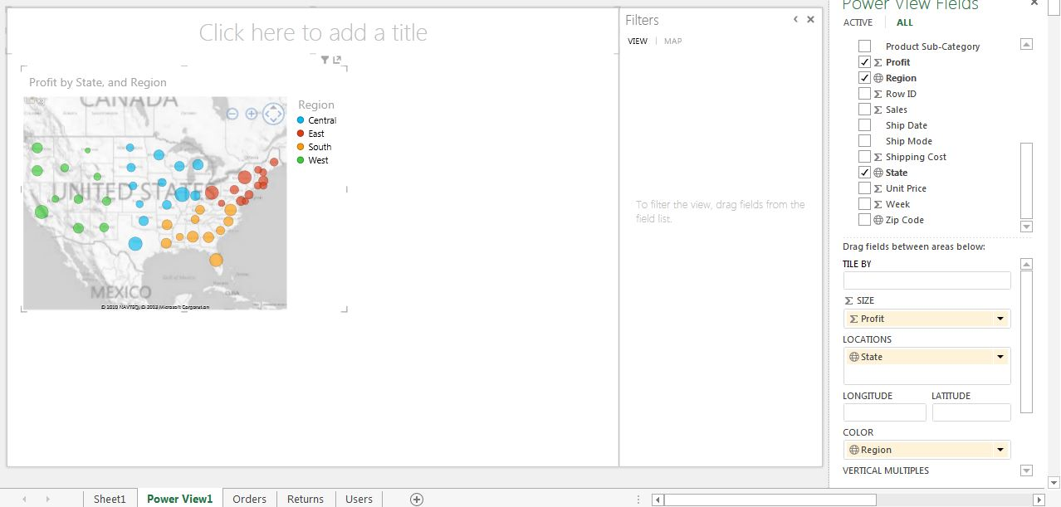

Profit by State (Map) (Power View)

This wasn't a complex task in Power View.  However, the points can only be displayed as pie charts, or circles in this case.  Also, the points can only be colored by a dimension, not an automatically discretized measure.  This chart looks nice, but it's difficult to discern too much information from this.  Let's see what Tableau can do.

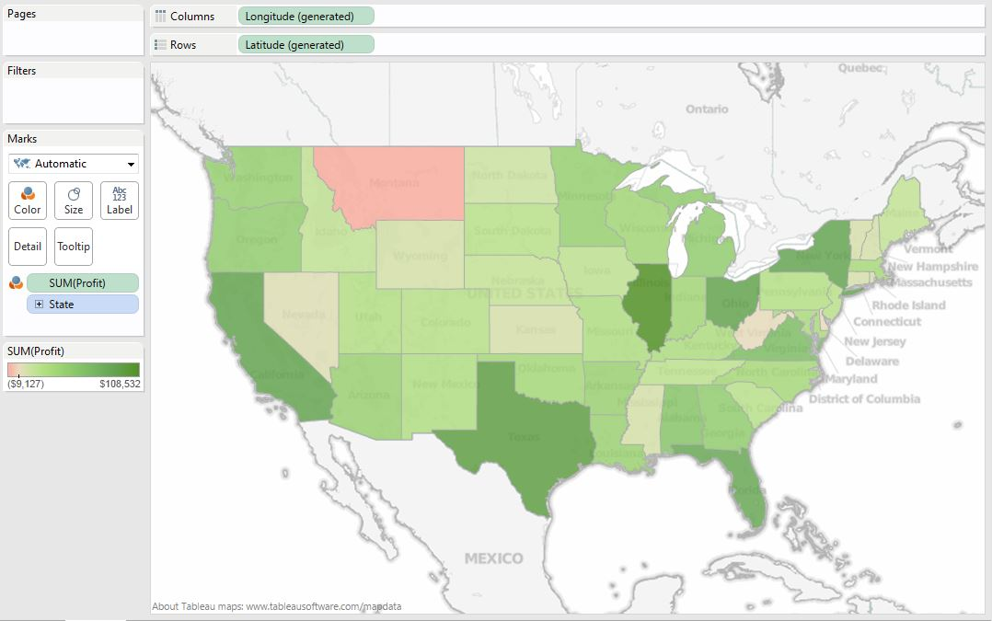

Profit by State (Map) (Tableau)

It took us three clicks to create this chart.  We think it's fair to say that this chart is much more aesthetically pleasing than the Power View chart.  Also, it's quite easy to discern which states are profitable and which ones aren't.  This is an easy decision.

*Winner: Tableau*

**Section Summary**

Now that we've gone through a few different important chart types, it's become apparent that Tableau is the better choice for basic charting.  We realize that Tableau is not easily capable of creating clustered bar charts, which we find extremely useful.  Perhaps they will introduce this feature in a later version.  Some of you might be screaming "What about Power Map?!?!"  We purposely left it out of this analysis, which is slightly unfair.  We wanted this to be "BASIC" charting.  Power Map, formerly GeoFlow is an extremely cool tool that allows the user to do a large amount of things related to mapping.  In fact, a colleague of ours, [Jason Thomas](http://www.linkedin.com/in/jasontomthomas), recently did a really cool webinar and a series of blog posts related to Geospatial Analysis in Power Map.  There will be a section in a later white paper that deals solely with mapping where we will introduce Power Map.  Thanks for reading.  We hope you found this informative.

# Basic Data Modeling

In this section, we will talk about how to handle data modeling in Power Pivot and Tableau.  To do this, we need to talk about the difference between "Joining" (Power Pivot) and "Blending" (Tableau).  A join is a static relationship that is reused over and over again for every calculation, with the exception of the ones you specifically code to reject that relationship.  Blending is a dynamic relationship that is used for one chart and one chart only.  Here's a simple example.

Imagine you have a fact table of sales per day with standard mm/dd/yyyy dates.  You also have a fully functional date dimension.  For those of you that don't know what a date dimension is, it's a table where you can find all of the information about a date.  Some example information would be Month, Year, Weekday/Weekend, Fiscal Quarter, Holiday Status, etc.  Here's a simple example of a date dimension.

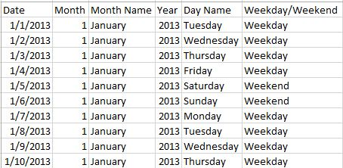

Date Dimension

Your goal is to report using the data from the main table, but the Month Name from the date table.  Now, if you wanted to "Join" these tables, you would want to join at the lowest possible level, i.e. the day.  This is so that you maintain as much information as possible in this STATIC relationship.  However, if you were to "Blend" these tables, you would only blend at the level you needed.  So, if you wanted to report on Sales per Month, you would still "Join" at the day level, but you would "Blend" at the Month level.  This is actually quite a neat feature.  If you wanted a report that shows the day level, the month level, and the year level (in different charts), you would have to "Join" at the day level, but you could "Blend" each chart at its respective level.  I have created a picture to illustrate this point.

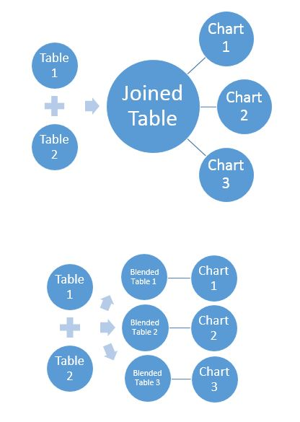

Join vs. Blend

Now, let's get to the examination.

**1 Fact and 1 Dimension**

Here, we have a dimension that shows the managers for each Region and the CEO, who is

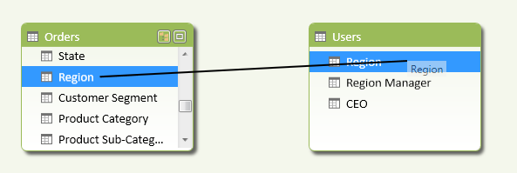

Orders to Users on Region (Power Pivot)

To define a relationship in Power Pivot, all you have to do is drag Region from Orders onto Region from Users.  Now, we can report on Profit by Region Manager.

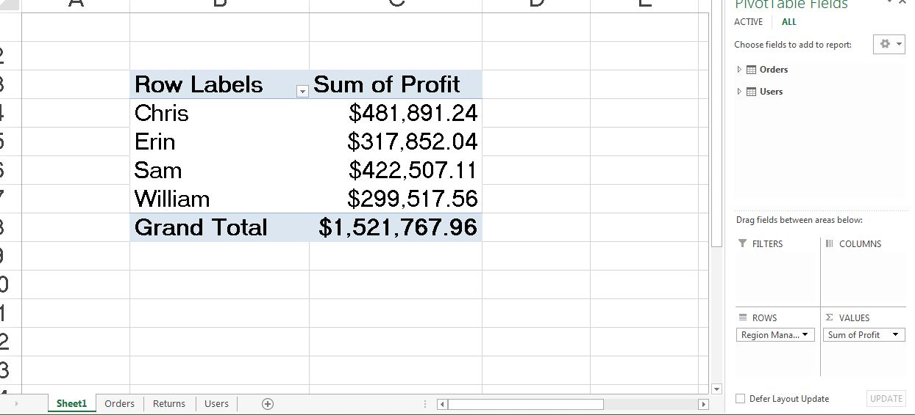

Profit by Region Manager (Power Pivot)

After creating the relationship, this was just as simple as if there were in the same table.  Now, let's see what Tableau thinks.

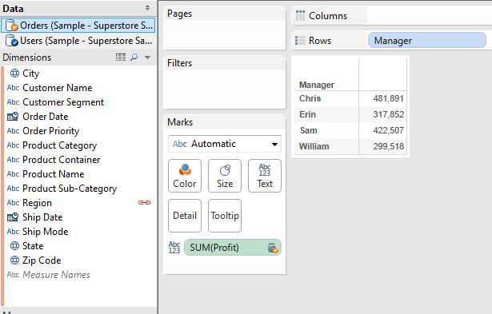

Profit by Region Manager (Tableau)

First, I had to drag Manager and Profit onto the chart.  However, since there's no Manager field in the Orders table, I had to click on the "Chain" beside Region to get it to blend on Region.  This would have been a much more complex task in Tableau 7.  However, Tableau 8 has had some serious changes to the way it blends.  In this case, both of the procedures were almost identical.

*Winner: Tie*

**1 Fact and 3 Dimensions**

Now, let's add a list of Returned orders as well as a Date dimension to the mix.  Let's see how well we can see how many orders were returned for each Region Manager in 2012.

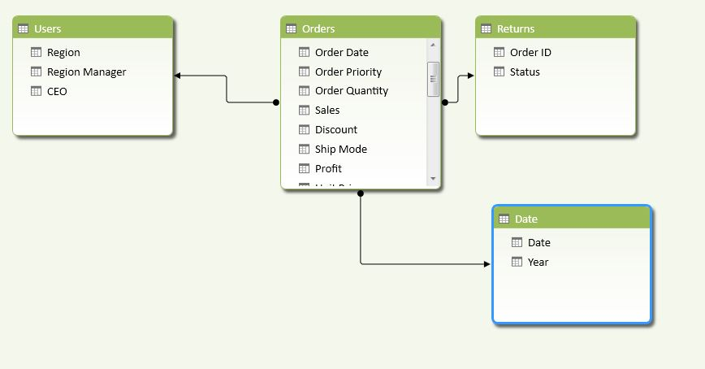

Orders to Users, Returns, Date (Power Pivot)

This design is what is typically called a Star Schema.  A star schema is widely considered, at least in my experience, to be the gold standard for analytical data modeling.  If you want to know more about Star Schema, check out the [Wikipedia article](http://en.wikipedia.org/wiki/Star_schema), which pays homage to [Ralph Kimball](http://www.kimballgroup.com/), the "father" of the Star Schema.

In Power Pivot, creating this was just a few drags.  However, before we can go to the pivot table, we have to create our measure.  In a Star Schema, the measures typically originate in the Fact table.  Therefore, we need to flag which orders were returned from inside the Fact Table.

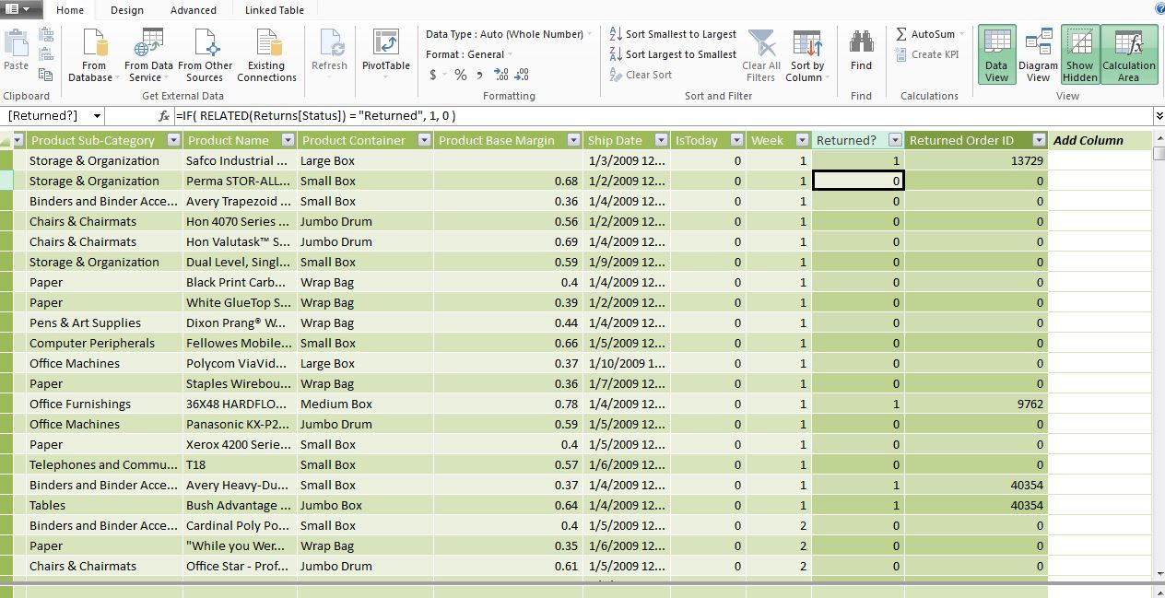

Returned? (Power Pivot)

Now, we will need to find a way to count the number of distinct orders that had returns.  To do this, we can add another calculated column.

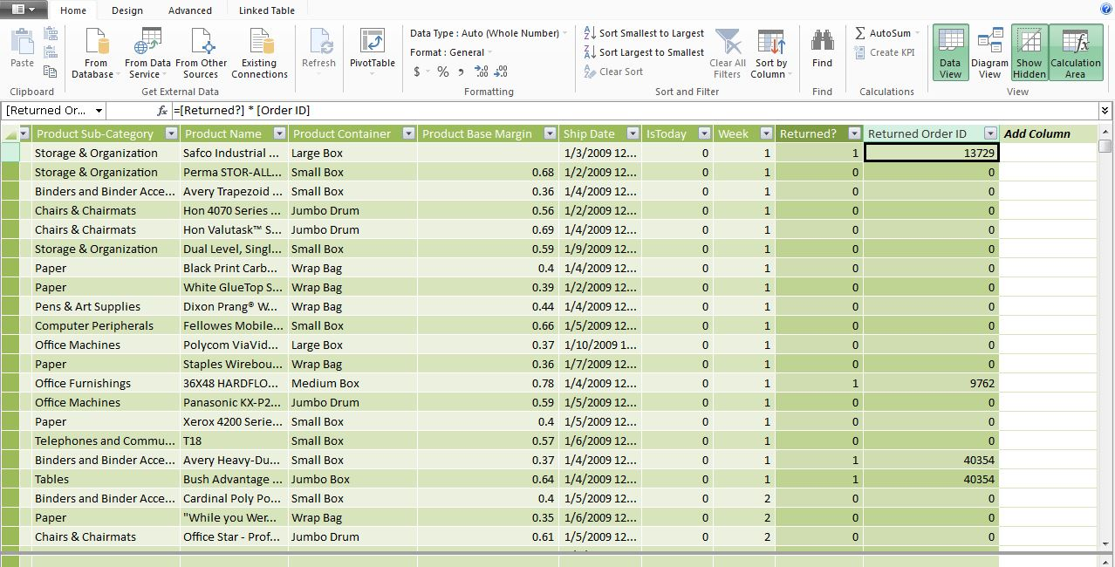

Returned Order ID (Power Pivot)

Now, we need to create a calculated field that performs a distinct count on this column and subtracts 1 to account for the zeros.

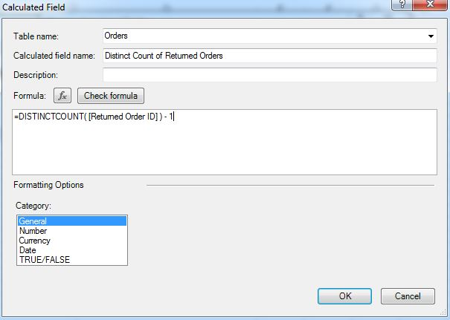

Distinct Count of Returned Orders (Power Pivot)

Finally, we can create our pivot table.

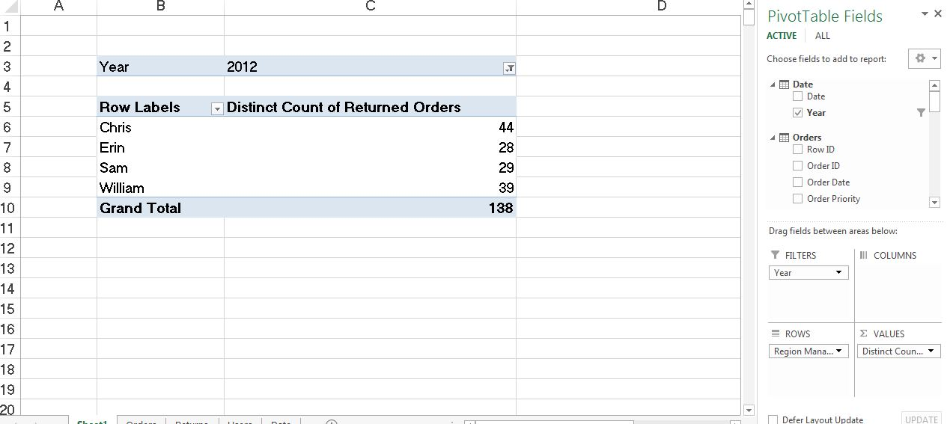

Number of Returned Orders in 2012 by Region Manager (Power Pivot)

This was a mess.  It required a decent knowledge of how Power Pivot worked.  The reason we had to distinct count was because the Orders table is at the Order Line level, and we wanted to know how many Orders were returned.

Now, we want to see how Tableau handles this. In order to do this, we need to introduce a feature we haven’t seen yet. This feature is very similar to Power Pivot’s drag-and-drop joining mechanic.

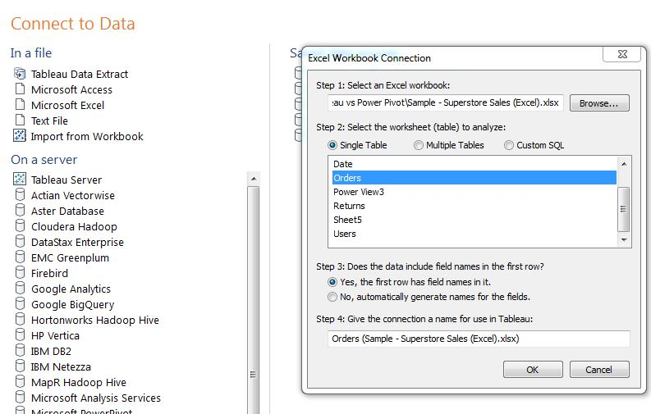

Create Excel Connection (Tableau)

First, we want to open a connection as if we are going to connect to the Orders table. Now, if we select the Orders table and click on the “Multiple Tables” radio button, we can actually join Orders to the other three tables.

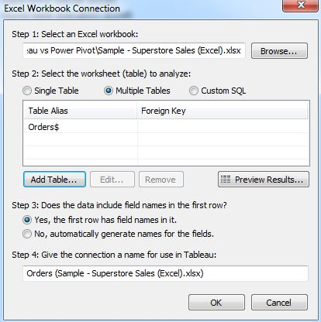

Create Excel Connection (Multiple Tables) (Tableau)

Now, we can click “Add Table…” and choose the “Date” table.

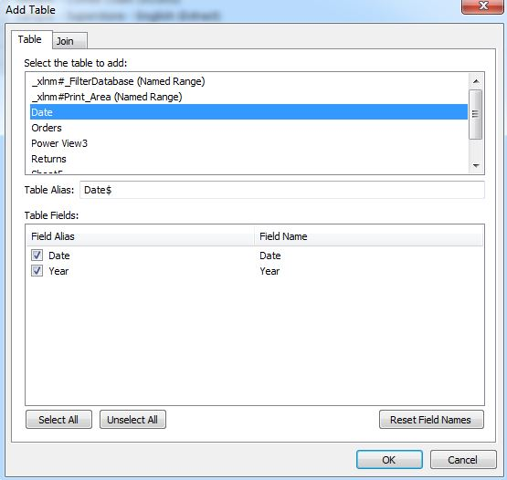

Add Table (Tableau)

On this screen, we can select the columns we can to bring across, which is all of them in this case. We could also double-click on the labels under “Field Alias” and change the names of the columns if we wanted. However, the real neat stuff is under the “Join” tab.

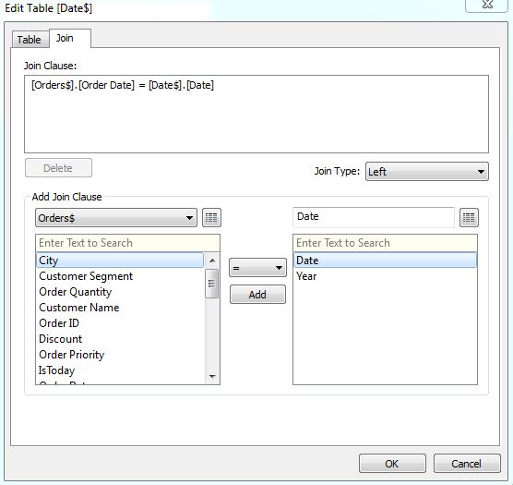

Join Table (Tableau)

If we select [Order Date] from the Orders table and [Date] from the Date table, then click “Add”, we will see that Tableau has created a join between those two tables. This is very similar to the way we joined tables in Power Pivot. It is also important to note that Tableau requires us to define our Join Type at the beginning. We need to create “Left Joins” for this example. We won’t get into Join Types here. However, it is important to note that Join Types are dealt with differently in Power Pivot, which we also won’t discuss at this time. Now, we need to click “OK” and repeat this process for the Returns and Users tables. Finally, for the really cool part. If we click on the “Custom SQL” radio button, we can see the query that Tableau created to pull together this data.

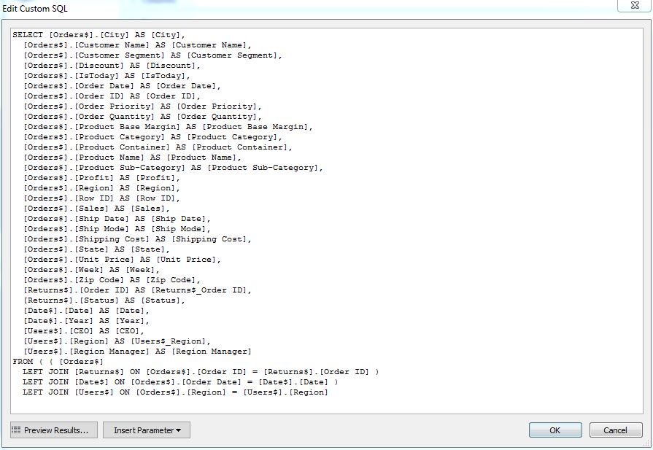

Custom SQL (Tableau)

If we were so inclined, we could even edit this SQL code to alter the tables however we wanted to. We can even insert parameters to create a live SQL connection that pulls different data based on a user’s selection. We won’t actually use the Custom SQL now, but it’s great to see that it’s there. Finally, we need to create an extract using this connection.

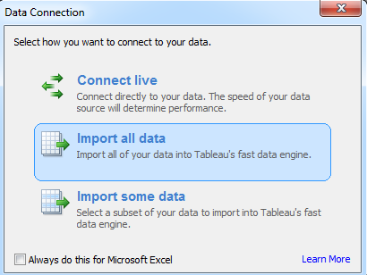

Import Data (Tableau)

We created an extract for two reasons. First, extracts will almost offer superior performance to live connections. Second, the distinct count function does not exist for live connections to Excel. Once we import the data, we can finally create our chart. We will skip a lot of the dialogue here because this section is identical to the way we did it in Power Pivot

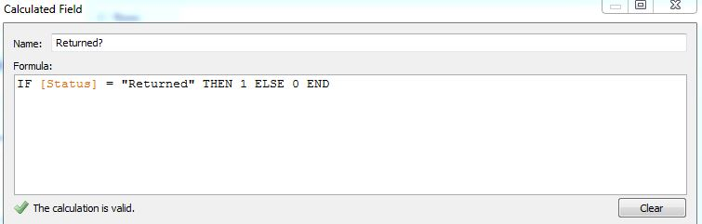

Returned? (Tableau)

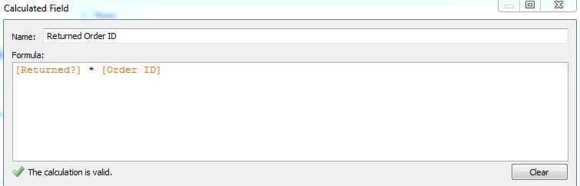

Returned Order ID (Tableau)

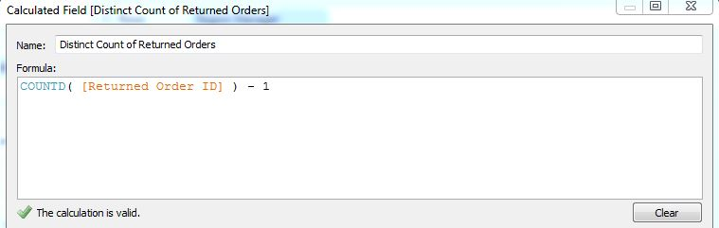

Distinct Count of Returned Orders (Tableau)

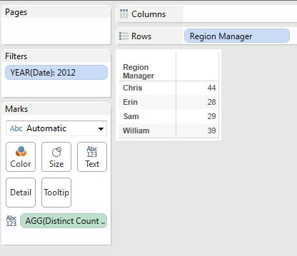

Number of Returned Orders in 2012 by Region Manager (Tableau)

As you can see, we got the same numbers as in Power Pivot. In fact, the procedure was almost identical. The most important difference was the fact that Tableau took quite a bit more effort to join the tables than Power Pivot. Because of this, we can easily decide the winner.

*Winner: Power Pivot*

**Section Summary**

This was a great exercise.  It showed that Tableau and Power Pivot can both handle basic data modeling. In fact, they handle it in almost the same manner. To be fair, both of the Tableau sections could have been handled using either Blending or Joining. However, we chose the easiest route to our answer for each situation. We’re excited to see how these tools fare when the models get more complex. Alas, that is a section for another paper.

# KPIs

In this section, we will talk about creating KPIs.  More generally, we will talk about creating more complex functions than simple aggregations.  One of the defining characteristics of a KPI is that it is a measure that cannot be calculated at the row or column level; it must be calculated in real time.  By this definition, KPIs are also non-additive or, less commonly, semi-additive.  KPIs are the backbone of most enterprise reporting and should weigh very heavily on the choice of a tool.  Therefore, we will attempt to examine them very closely.  We will look at three types of KPIs: Simple Ratios, Filtered Ratios and Lookups. In this section, we will use the Superstore Sales sample data set from Tableau.

**Simple Ratio (Profit Margin)**

Unfiltered Ratios are some of the simplest KPIs.  So let's look at how to calculate Profit Ratio by Region in Power Pivot.

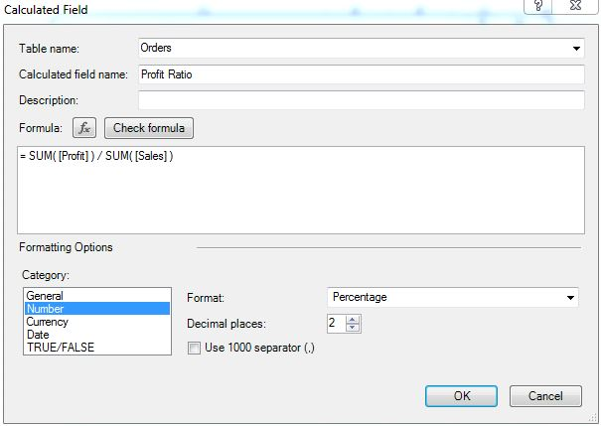

Profit Ratio (Power Pivot)

This calculation is quite simple.  It's also nice that Power Pivot lets you select the format here.

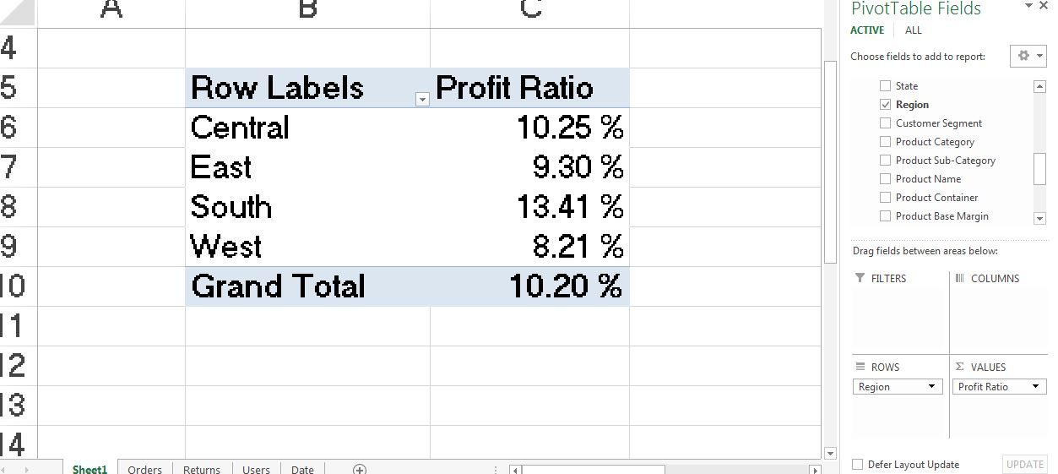

Profit Ratio by Region (Power Pivot)

As you can see, this was simply one calculation and two drags.  Let's see how Tableau fares.

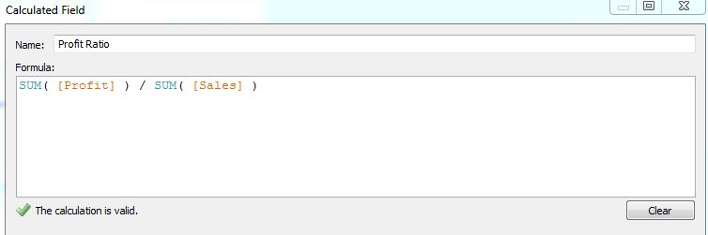

Profit Ratio (Tableau)

This formula is just as simple as the one for Power Pivot.  Now, on to the chart.

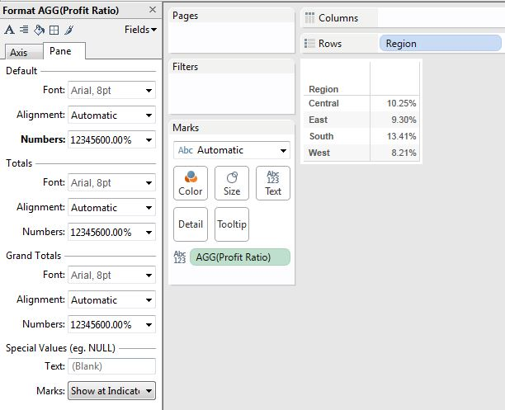

Profit Ratio by Region (Tableau)

This chart looks identical to the Power Pivot chart.  However, we did have to go through one extra menu to set the format of the KPI.  Also, you might notice that Power Pivot is showing a total while Tableau is not.  For KPIs, totals may or may not be significant.  Since this is such a situational need, we do not consider it when deciding our verdict.  The extra menu was enough to give Power Pivot the edge in this category.

*Winner: Power Pivot*

**Filtered Ratios**

To the untrained user, a filtered ratio is the same as a simple ratio.  They simply see it as a non-additive measure.  However, they are much more complex to create because the creator must have an awareness of the current filters, as well as how to alter them.  Let's see how Percent of Total Sales per Category works in Power Pivot.

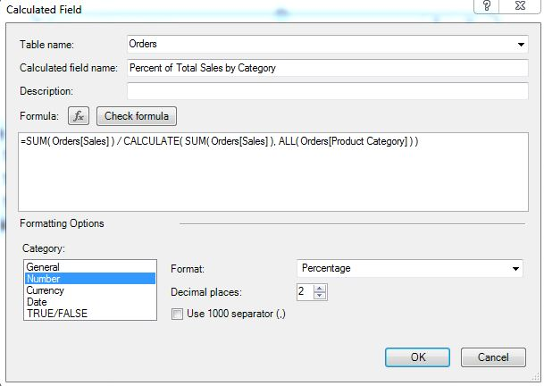

Percent of Total Sales (Power Pivot)

The calculation leverages this nifty ALL() function which does the heavy lifting for us.  Now, on to the pivot table.

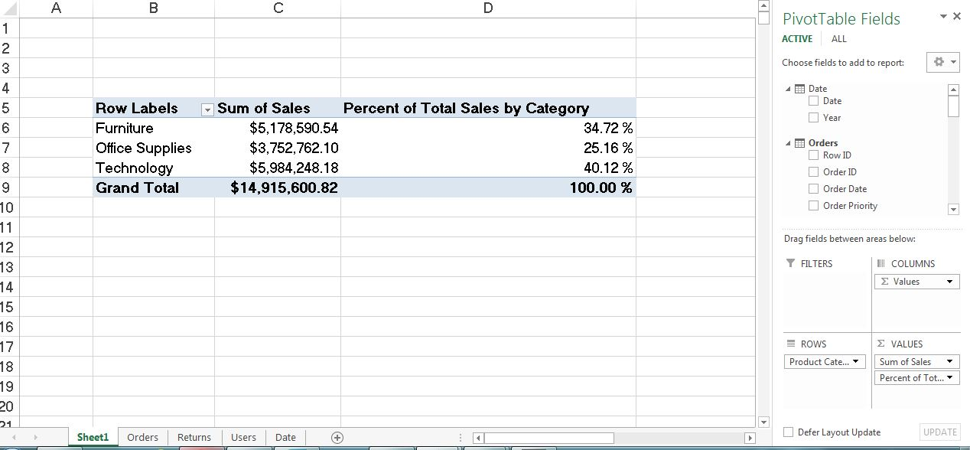

Percent of Total Sales by Category (Power Pivot)

As usual, the pivot table was a breeze to create.  Let's give Tableau a shot.

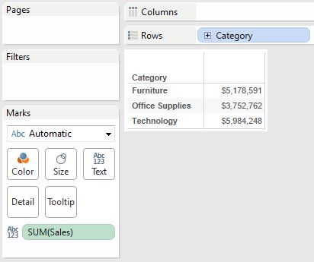

Sales by Category (Tableau)

In typical Tableau fashion, we have to make our chart first.  Now, let's take a look at the calculation.

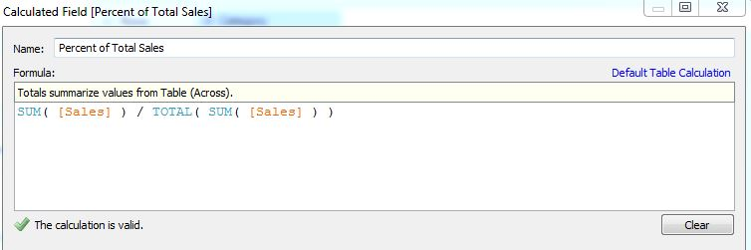

Percent of Total Sales (Tableau)

Just like with Power Pivot, we can leverage a nice function here.  In fact, the TOTAL() function in Tableau works pretty similarly to the ALL() function in Tableau.  Finally, on to the chart.

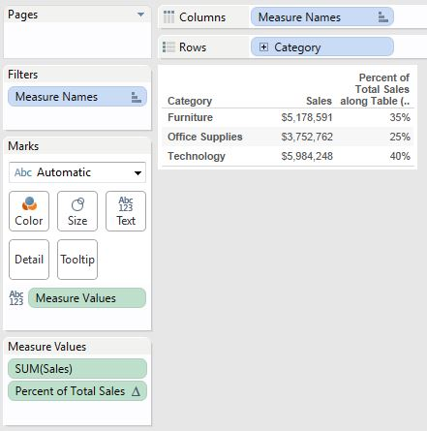

Percent of Total Sales by Category (Tableau)

As usual, creating the charts is a drag-and-drop experience.  These exercises seemed almost identical between the tools.  They both leveraged similar functions to accomplish an identical task.  Not much else to say about it.

*Winner: Tie*

**Lookups (Previous Year's Sales)**

Lookups are another important part of KPIs.  Many companies like to compare KPIs for this period to KPIs from a previous period.  Let's see how it's done in Power Pivot.

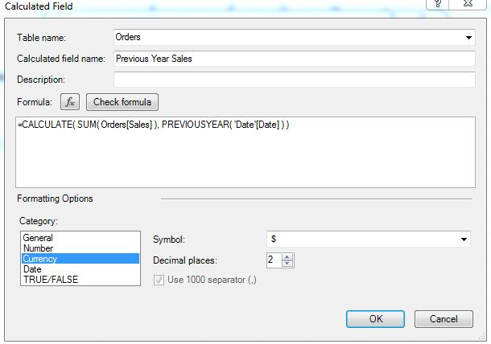

Previous Year Sales (Power Pivot)

This DAX expression is more complex than the last one.  Power Pivot prefers your data to be in a Star Schema.  Therefore, many of the DAX functions, especially the time intelligence ones, will leverage this.  However, this also means that there is a learning curve associated with these functions.  Let's check out the pivot table.

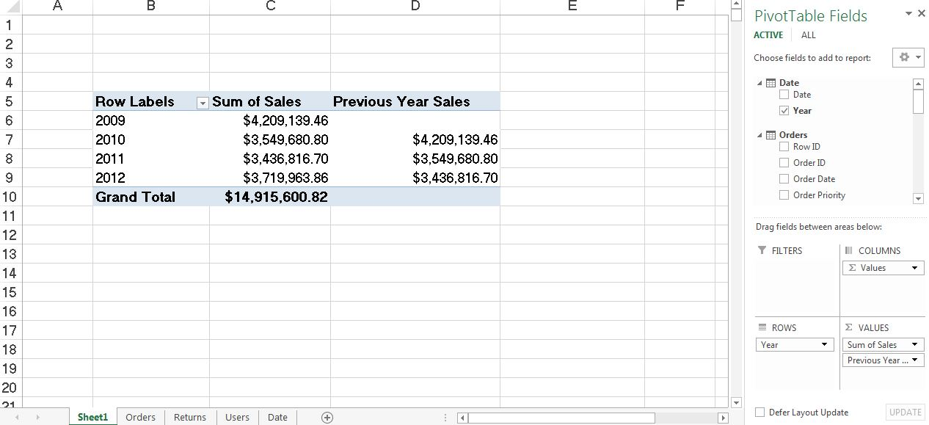

Previous Year Sales by Year (Power Pivot)

The pivot table was easy to create once the DAX was finished.  Let's check out Tableau.  Remember that Tableau table calculations work based on what's in the chart.  So, we have to make our chart first; then we can calculate our KPIs.

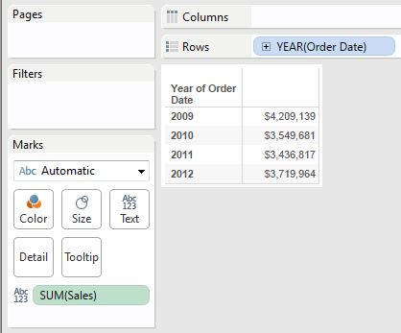

Sales by Year (Tableau)

Now, we can make our calculation.

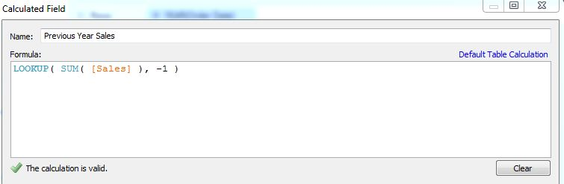

Previous Year Sales (Tableau)

Finally, we can finish our chart.

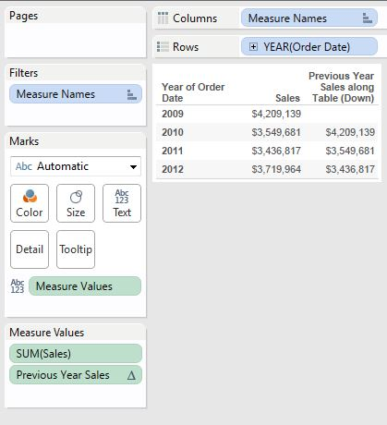

Previous Year Sales by Year (Tableau)

This wasn't too complicated if you know how table calculations work.  The predicament is this: We took two very different paths to get these answers.  So, how do we compare?  Personally, we feel that Tableau's "Canvas" concept is a little bit easier to grasp because it focuses on what you can already see in front of you.  However, Power Pivot has this handy PREVIOUSYEAR() function which almost does the work for you.  Therefore, we can't make up our minds on this one.

*Winner: Tie*

**Section Summary**

All in all, there's not much of a difference between the difficulties of using these tools.  Tableau's "Canvas" concept is very intuitive; however, it always makes you go through extra steps to get the formatting right.  Power Pivot seems to finish much cleaner; however, it requires a pretty star schema behind it (which does take time to create).  Therefore, we'll call this whole part a tie.  If you are looking to create these simple KPIs, feel free to pick the tool that you like best.

The knowledgeable reader may notice that we left out very cool features for both of these tools. These features are Tableau’s Quick Table Calculation feature and Power Pivot’s KPI feature. These features are incredibly useful for the business user and will be devoted an entire section in our next paper.

# Summary Results

This examination turned out pretty well. Here are the results:

|  |  |  |  |
| --- | --- | --- | --- |
| **Basic Functionality** | **Tableau** | **Power Pivot** | **Tie** |
| Data Connectivity | X |  |  |
| Quick Answers from Clean Data |  | X |  |
| Basic Typecasting |  | X |  |
| **Basic Charting** |  |  |  |
| One-Dimensional Bar Graph | X |  |  |
| Two-Dimensional Bar Graph |  | X |  |
| Scatterplot | X |  |  |
| **Basic Data Modeling** |  |  |  |
| One Fact, One Dimension |  |  | X |
| One Fact, Three Dimensions |  | X |  |
| **KPIs** |  |  |  |
| Simple Ratio |  | X |  |
| Filtered Ratio |  |  | X |
| Lookup |  |  | X |

It seems that, at least for the basics, Tableau has a slight edge when it comes to visualizations and Power Pivot is slightly stronger at data modeling. However, it’s not so simple to pick one because no job is complete without both visualizations and data modeling. Therefore, use the tools for their skills. If you have some serious modeling to do, put your data in Power Pivot. If you want to make some really cool charts, use Tableau. If you need both of these, there’s no reason you can’t use your Power Pivot model as your data source in Tableau. This way, you get the best of both worlds. Thanks for reading. Stay tuned for our next white paper where we compare these tools in more complex scenarios.

# About the Author

|  |  |
| --- | --- |
|  | Brad Llewellyn, Associate Data Analytics Consultant Brad Llewellyn is a Statistician, Data Miner, and Visualizations Expert for Mariner in Charlotte, NC. Brad enjoys his role as a consultant and loves the new challenges it brings each day. He hopes to help bring Mariner and all of its clients fully into the world of Predictive Analytics.  Connect with Brad on LinkedIn <http://www.linkedin.com/in/bradllewellyn> |
|  |  |

# About Mariner

For more than a decade, Mariner has been helping clients leverage their data - from any data source to any device - through the use of business intelligence, analytics, data warehousing, business scorecards and performance management dashboards. Mariner serves clients in a variety of industries including utility, healthcare, education, media and manufacturing sectors. Singularly focused on providing analytic solutions, we help business people organize, use, analyze and share data to improve sales, customer service, logistics, productivity and financial insight. Mariner is a Microsoft Certified Gold Partner with competencies in Business Intelligence and Data Platform. Mariner-Insight to Achieve. [www.mariner-usa.com](http://www.mariner-usa.com). For more information about the XX solution, visit [www.mariner-usa.com/XX](http://www.mariner-usa.com/XX) .

## Copyright Information

The information contained in this document should not be interpreted to be a commitment on the part of Mariner and Mariner cannot guarantee the accuracy of any information presented after the date of publication.

This white paper is for informational purposes only. MARINER MAKES NO WARRANTIES, EXPRESS OR IMPLIED, IN THIS DOCUMENT. Complying with all applicable copyright laws is the responsibility of the user. Without limiting the rights under copyright, no part of this document may be reproduced, stored in, or introduced into a retrieval system, or transmitted in any form or by any means (electronic, mechanical, photocopying, recording, or otherwise), or for any purpose, without the express written permission of MARINER, LLC. © 2012 MARINER, LLC. All rights reserved. The names of actual companies and products mentioned herein may be the trademarks of their respective owners.